Project Design Phase-II

# Data Flow Diagram &User Stories

|  |  |
| --- | --- |
| Date | 15 October 2022 |
| Team ID | PNT2022TMID28524 |
| Project Name | Natural Disaster Intensity Analysis and  Classification Using Artificial Intelligence. |
| Maximum Marks | 4 Marks |

**Data Flow Diagrams:** A Data Flow Diagram (DFD) is a traditional visual representation of the information flows within a system. A neat and clear DFD can depict the right amount of the system requirement graphically. It shows how data enters and leaves the system, what changes the information, and where data is stored.

**Example:**

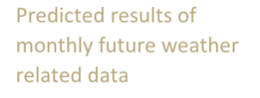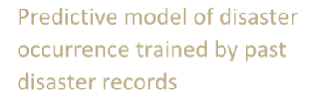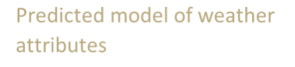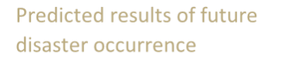

Predictive model of disaster occurrence trained by past disaster records

Past weather data records

Predicted results of future disaster occurrence

Predicted results of monthly future weather related data

Predicted model of weather attributes



|  |  |  |  |
| --- | --- | --- | --- |
|  | External entity like hurricane, cyclones  By using convolution neural network  Predicting  the Predicting  Cyclone Data in the form of severity of image or dataset a cyclone  Existing  image  Data stored by RNN | | |
|  |  | Victims |  |

|  |  |
| --- | --- |
| Past disaster data records |  |

# User Stories:

.

|  |  |  |  |  |  |  |
| --- | --- | --- | --- | --- | --- | --- |
| **User Type** | **Functional**  **Requirement (Epic)** | **User**  **Story Number** | **User Story / Task** | **Acceptance criteria** | **Priority** | **Release** |
| Customer (Mobile user) | Registration | USN-1 | As a user, I can register for the application by entering my email, password, and confirming my  password. | I can access my account / dashboard | High | Sprint-1 |
|  |  | USN-2 | As a user, I will receive confirmation email once I have registered for the  application | I can receive confirmation email &  click confirm | High | Sprint-1 |
|  |  | USN-3 | As a user, I can register for the application through Facebook | I can register & access the dashboard with Facebook Login | Low | Sprint-2 |
|  |  | USN-4 | As a user, I can register for the  application through Gmail | I can login with my  password | Medium | Sprint-1 |
|  | Login | USN-5 | As a user, I can log into the application by entering email & password | I can see the dashboard now | High | Sprint-1 |
|  | Dashboard | USN-6 | As a user, I can update Disaster incidents. | I can update now. | Medium | Sprint-1 |
| Customer (Web user) |  | USN-7 | As a user, I can view Map Data. | I can see Map Data. | Medium | Sprint-1 |
| Customer Care Executive | Authentication | USN-8 | As a Community Leader, I can log  into the application using my password | I can access my account. | High | Sprint-1 |

|  |  |  |  |  |  |  |
| --- | --- | --- | --- | --- | --- | --- |
|  |  | USN-9 | As a Community Leader, I can apply for membership. | I can apply membership. | High | Sprint-1 |
| **User Type** | **Functional Requirement (Epic)** | **User Story Number** | **User Story / Task** | **Acceptance criteria** | **Priority** | **Release** |
|  |  | USN-10 | As a Community Leader, I can verify Disaster. | Disaster verification | High | Sprint-1 |
| System Administrator | Membership Approval | USN-11 | As a administrator, I can approve the Membership application. | I can approve membership. | High | Sprint-1 |
|  | Update  Disaster information | USN-12 | As a administrator, I can update information about Disaster. | I can update disaster information. | High | Sprint-1 |
|  | Disaster  verification | USN-13 | As a administrator, I can verify  disaster. | I can verify Disaster | High | Sprint-1 |
| Community Leader and System  Administrator | Disaster Queries | USN-14 | Both are can able to ask disaster queries. | We can ask Queries about disaster. | Low | Sprint-2 |
|  | Disaster Reports | USN-15 | Both are can able to give disaster reports. | Both will give the disaster reports | Low | Sprint-2 |